Task Management System

- Login Page :- ( when open first time )

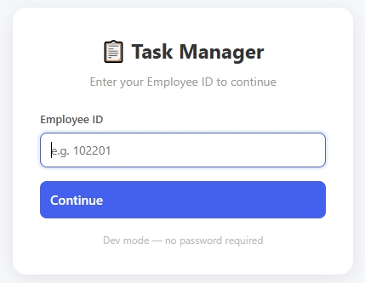

How to Use :
- Just enter your employee id

- After Login visiable UI :-

- After login, the “My Tasks” page will open by default.
- Initially, it will be empty because no tasks have been assigned yet.

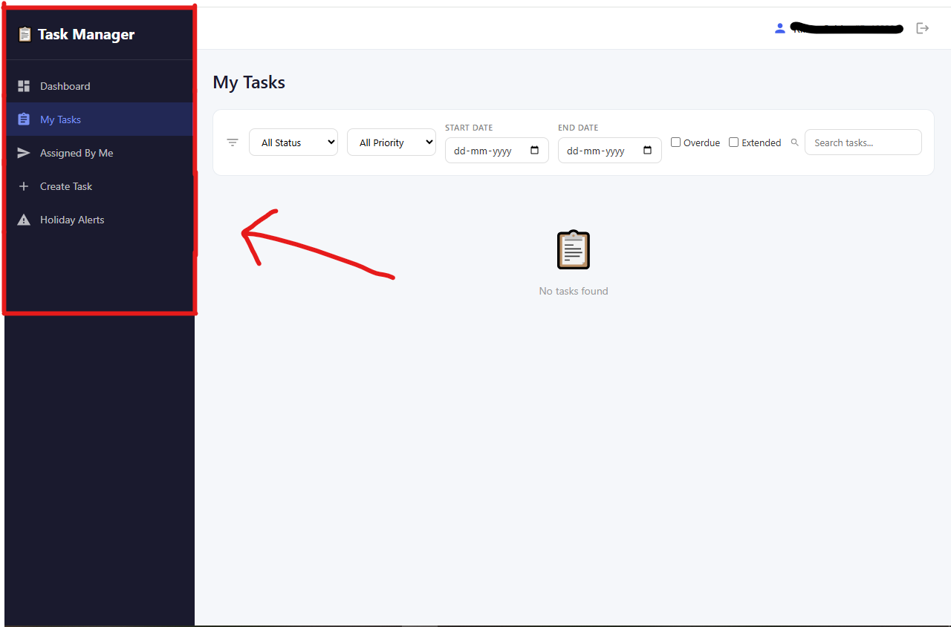

Navigation Menu :- On left side of UI
How to Use : Using the navigation menu you can access the following pages as shown in above image

- Dashboard Page
- My task Page
- Assigned By Me Page
- Create Task
- Holiday Alerts

Note :- Now Lets understad and explore the UI in detailed while assinging the new task to employee

- Create Task Page :-

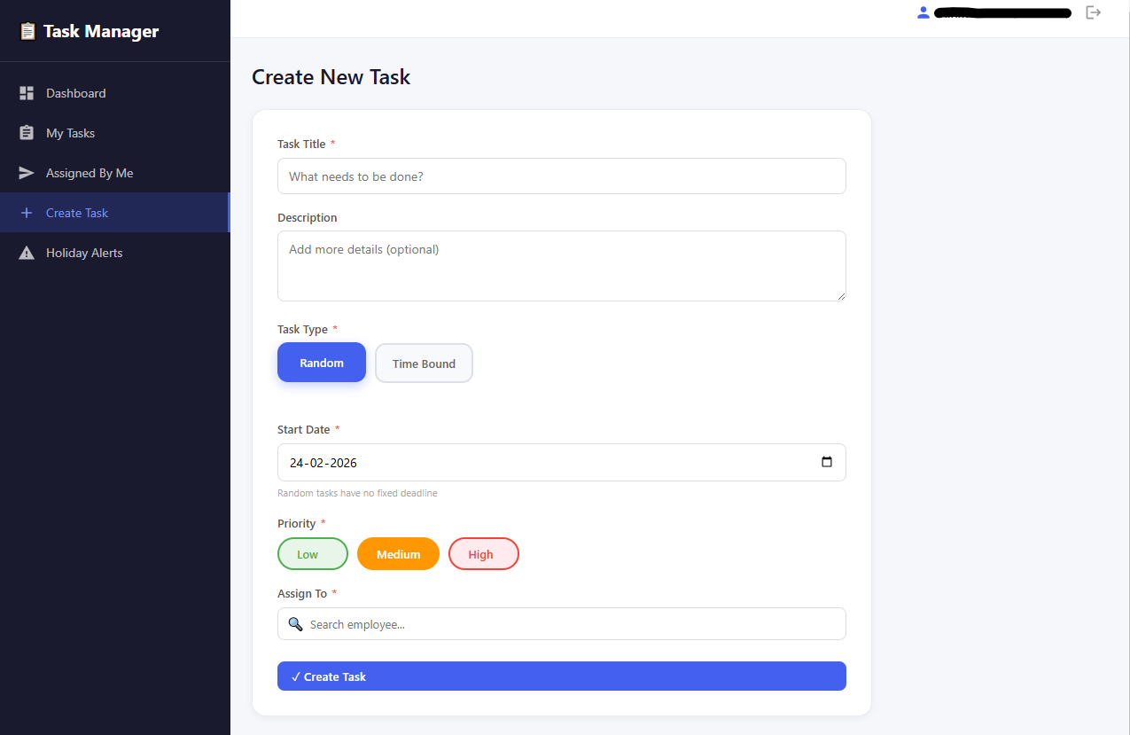
How to Use : fill the all field of the form visiable in above image

- Enter Task Title
- Enter the Task description
- Select the task type :- based on task type the number of date field will be chnaged

- Task Type :- Random

Note:- Random task type is considered as one day task it means the task start date and end date are same

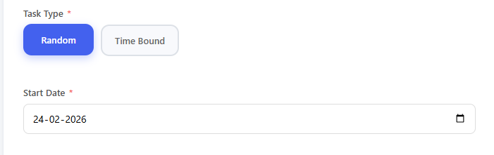

- Task Type :- Time-Bound

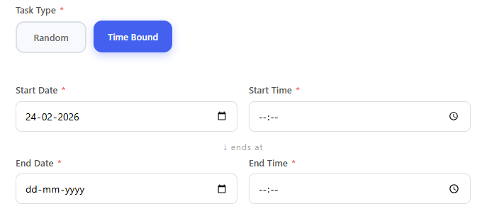

Note :- After clicking on the ‘Time Bound’ you can see their are more fields to set date and time compare to ‘Random’. it is maditory to fill all visiable fields

- Task Priority type :- Based on the task urgency or importance choose (click) the task priority such as low, medium, high

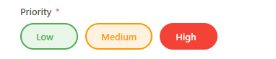
Note :- If the task is important and needs to be completed first, select “High” priority as shown in the image above.

- Assign To :-
- Select the employee to whom the task will be assigned.
-You can search for an employee by ‘Name’ or ‘Department’.

Note: A task can be assigned to one or multiple employees. For example, one task can be assigned to up to 10 employees. As showm in below image

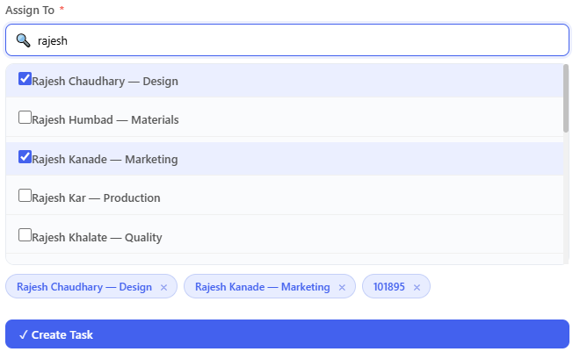

- Click on ‘Create Task’ :- as shown in above image it is last step to assign task

- Assigned By Me Page :- Here, you can see the tasks that you have assigned to other employees.

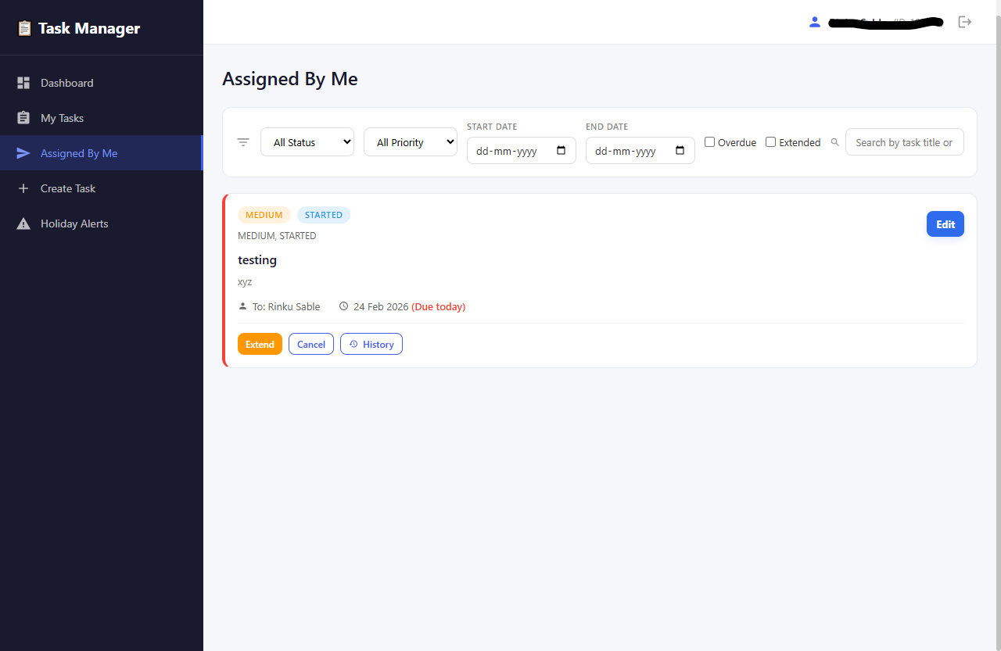

Filters :- Here, you can apply filters to view tasks based on criteria such as date, status, priority, or assigned employee.

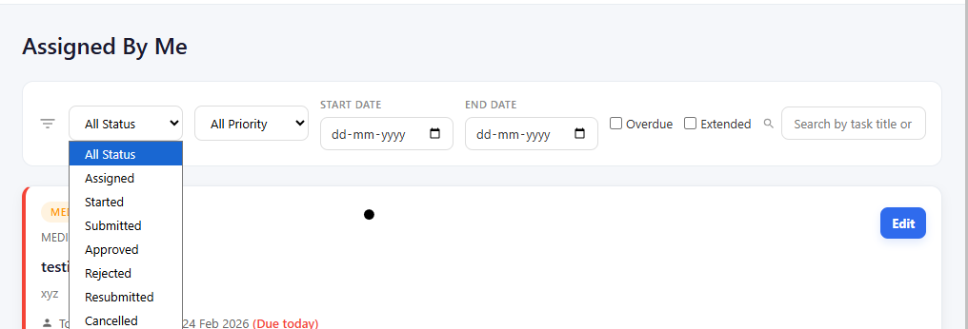

How to Use: -

- Status :- filter tasks based on status such as All status(default), assigned, started, submitted, etc
- Priority :- filter task based on different Task Priority such as all(default) , low, medium, high .
- Start Date and End Date :- You can search for tasks between two dates, or select only a start date or only an end date to filter the results based on the starting or ending point.
- Overdue :- To search only overdue task check this box
- Extended :- To search only Extended task check this box
- Search :- User can search by ‘Task Name’ or ‘Employee Name’
Task Card :- Here, you can see the task details such as title, description, employee name, end date, task status , task priority , due day (or remaining day / overdue day count)

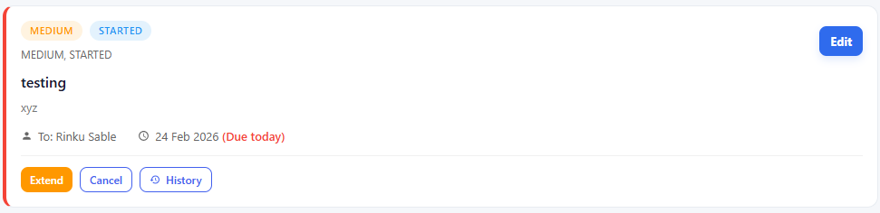

There are four important buttons available. Their information and uses are as follows:

- Extend button :- using the extend button user can extend the end date of the task if need

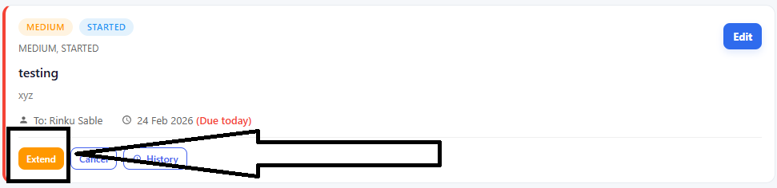

After clicking the extend button the new field to enter select extended date and remark (reason) will be appear as shown in following image

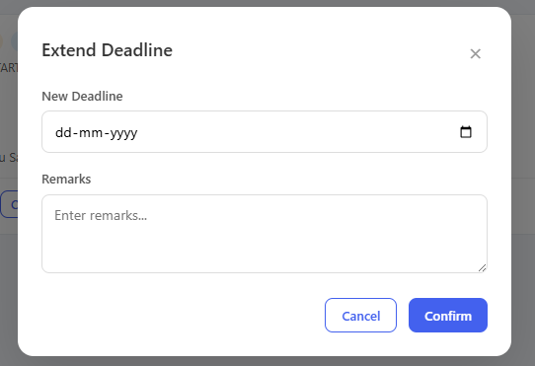

- Cancel button :- this button allow user to terminate the task completely

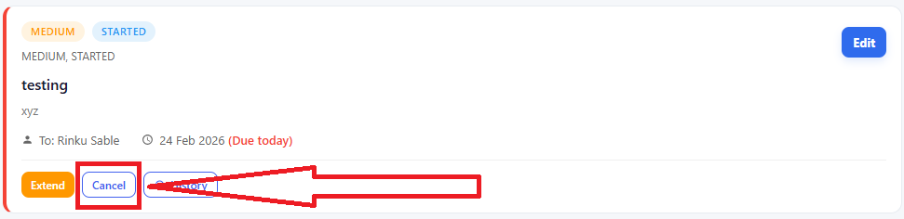

- History button :- Here, user can see the history of this task

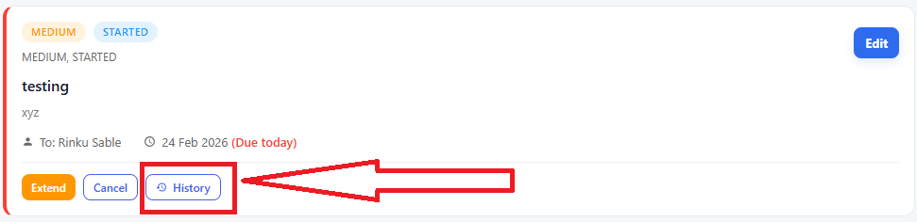

After the cl;icking the History button the it will redirect user ti task history page as shown in following page

Note:- it will only show history of selected task not all tasks

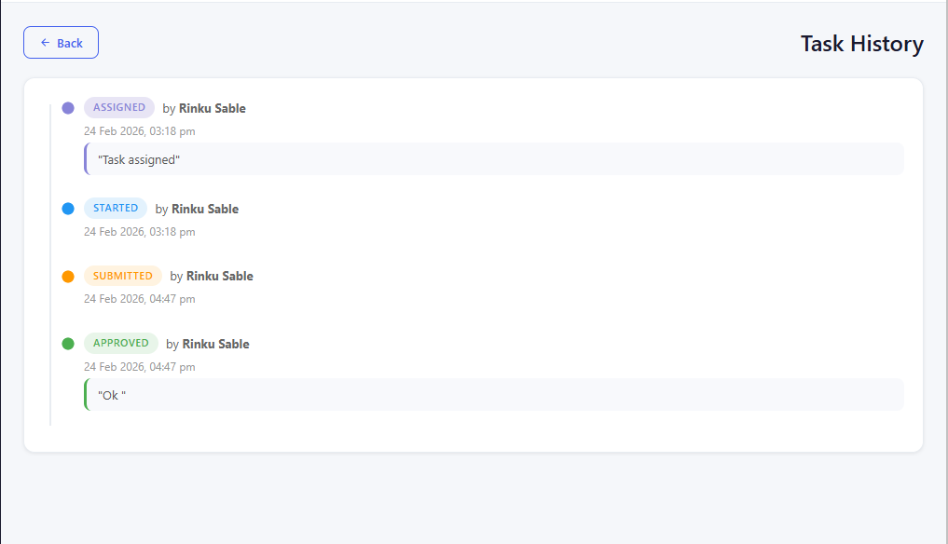
Here, task same task assinger and employee both are same in real time working both will different

- Edit button :- If the user wants to edit task details or add more employees to a task, they can do so even after the task has been assigned.
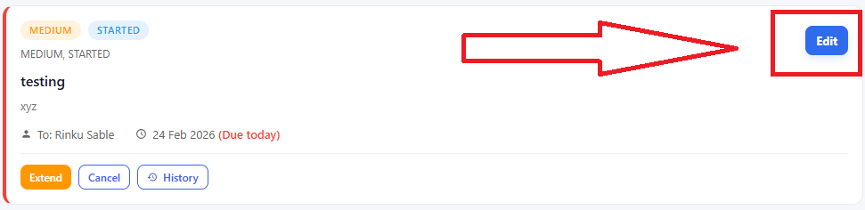

After clicking the Edit button, a new form will appear where you can update the existing details, as shown in the image below.

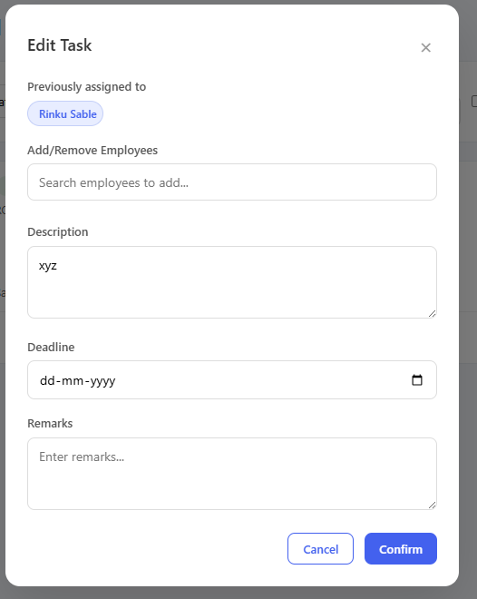

- My Task Page :-Here, employees can see the tasks that have been assigned to them.

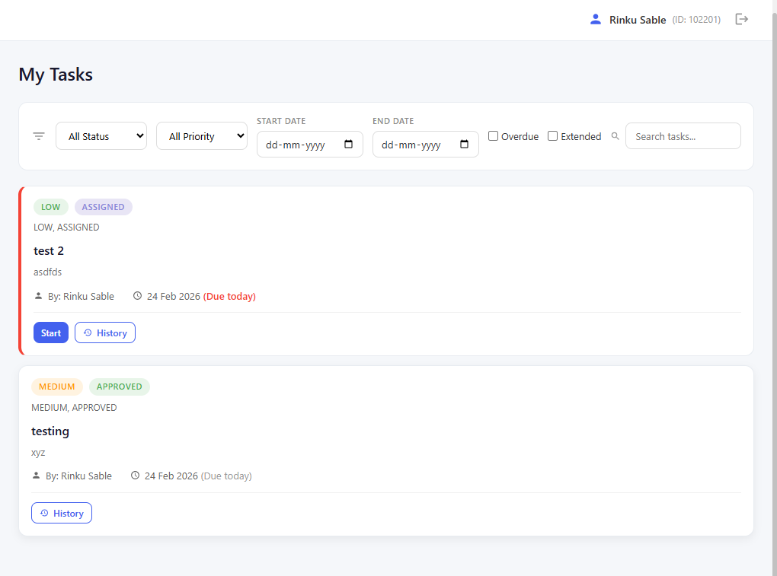
Filters:- Here filters are same as previously explain in the ‘Assign by me ‘ Page

Buttons:- Here, employee has only provided with two buttons
- first buttons :- Start\ Submit\ Resubmit
- History :- same as previously explain

- Holiday Alters :- If the start date or end date falls on a holiday, the system will display a message asking the user whether to shift the date to the next working day or keep the original date as it is as shown in following image .
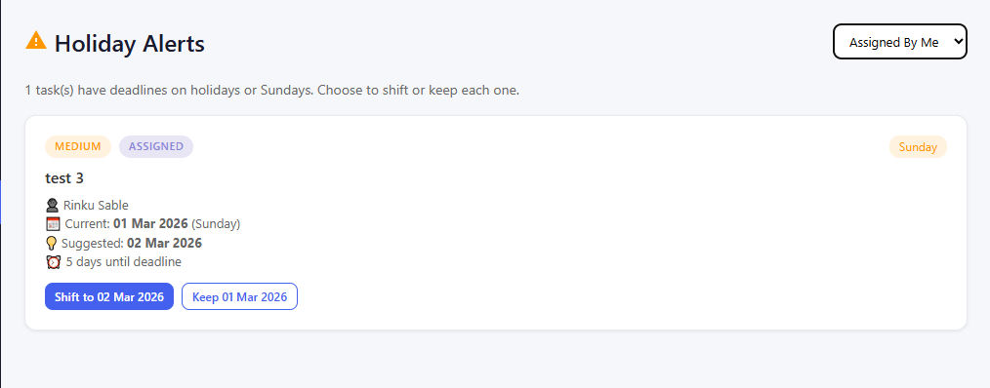

Note: For now, only Sundays and the holidays declared and added in the Holiday Master table are considered as holidays for this project.

At top- right there is option to switch role from manager to employee as vice versa

note:- manager term used as authority to assign task not employee’s position in company

- Dashboard Page :- Dashboard Page: Here, the user can see an overview of task statistics, including total tasks, completed tasks, pending tasks, and overdue tasks, along with visualizations such as charts and graphs for better understanding and analysis.

